HACKATHON

**LIFE EXPECTANCY POWER BI ANALYSIS**

**About the dataset**

The Global Health Observatory (GHO) data repository under World Health Organization (WHO) keeps track of the health status as well as many other related factors for all countries The data-sets are made available to public for the purpose of health data analysis. The data-set related to life expectancy, health factors for many countries has been collected from the same WHO data repository website and its corresponding economic data was collected from United Nation website.

**Analysis**

The above is a slicer showing the years in which WHO’s life expectancys are shown in the data

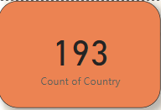

The above is a marks card for the total number of countries in the dataset

The above is a slicer for selecting the countries and getting the analysis based on the specific country

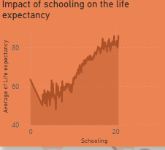

From this area graph we can see that as the schooling increases the average life expectancy also increases. This means that proper education to the people increases the lifespan in them

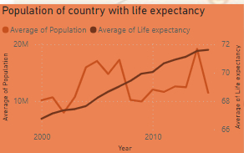

From this line chart we can see that the average of life expectancy keeps increasing while the population falls towards the end. This is due to large variations of population in the data set.

From this scatter plot we can see that United States has the highest expenditure and highest life expectancy, followed by Micronesia and then rest of the countries. This means that United States has a better lifestyle as compared to the other countries.

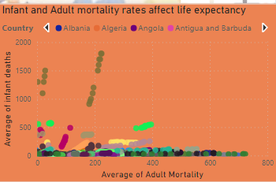

From this scatter plot we can see that the average the infant mortality rate in India is much higher throughout the years whereas the adult mortality rate in the country is pretty low. The numbers are high due to lack of facilities at primary health centers, such as doctors, beds, clean water, bathrooms, and even shortage of transport to urban hospitals where specialized care can be given to the infants.

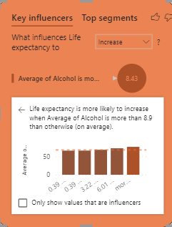

Through this key influencers we can see that as people consume more of alcohol the life expectancy is meant to be increased.